From consuming to conserving
This was not just another journey; it was truly a once-in-a-lifetime experience. I have travelled to many places seeking the beauty of nature — to breathe clean air, to recharge myself, and to celebrate the sense of achievement that comes with exploration. Yet, I realized it was always about consuming from nature, with little thought of conserving. It was always about me.
The major segments that moved me through out:
We often speak more about our rights than our responsibilities. But nature itself is built on the principle: what comes from the earth, returns to the earth. When I met the villagers and witnessed their deep respect for Mother Earth, the illusion I carried — that my small acts of sustainability were significant — dissolved. I understood that what I had been doing was not extraordinary, but merely the bare minimum.

Stepping into the fields for the very first time shook me to my core. I could suddenly see the immense effort, time, resources, and the struggle of nature behind that single handful of rice I eat every day. In those three days, everything I had taken for granted flashed before my eyes. It was a period of intense introspection, nudging me to contribute whatever strength I have.

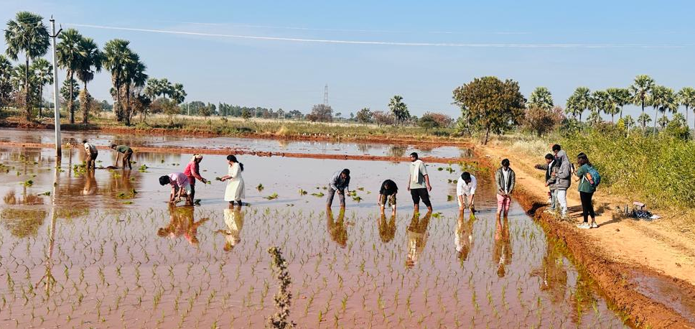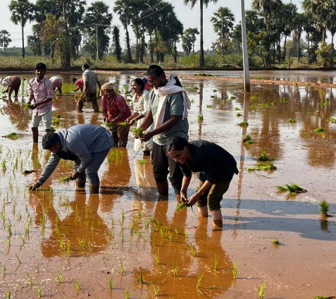
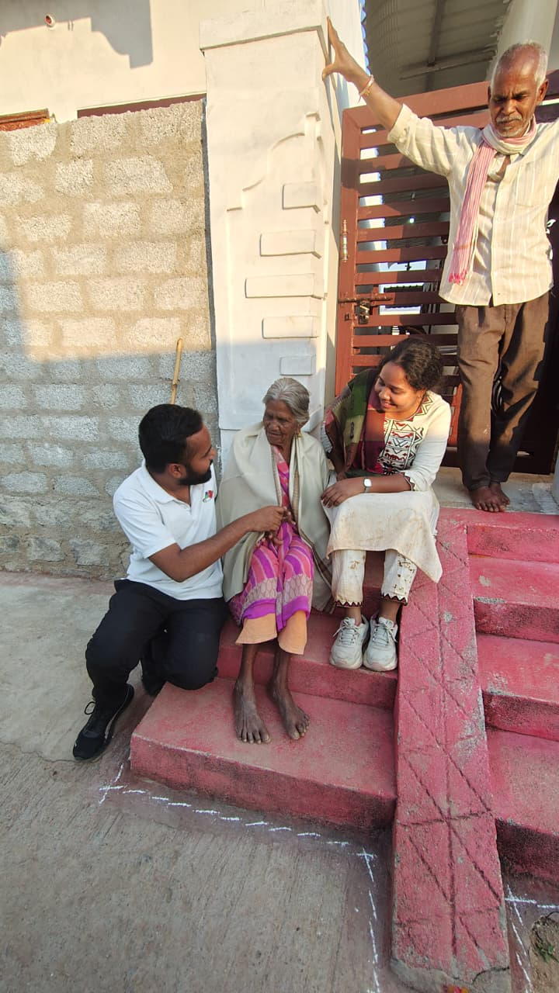
We speak of equality often, yet we forget that standing for others is just as vital as standing for ourselves. This truth came alive when Ganeshan sir asked us to reflect on it in the moment — and I am grateful for that awakening.

Nature creates everything with purpose, even a speck of dust. Then how can any plant be dismissed as waste? Perhaps it is only misplaced, waiting for the right hands to reveal its purpose. I saw those hands and I felt blessed to discover the wealth of medicinal plants around me.
Though I met my fellow yatris for the first time, it felt as though I had known them forever. Each shared unique insights about life and living. Beginning the journey by making myself zero became the benchmark for gaining knowledge and humility. The villages, the villagers, their perspectives, their minimalism, their struggles and solutions — all of it pushed me to think beyond self-centeredness.
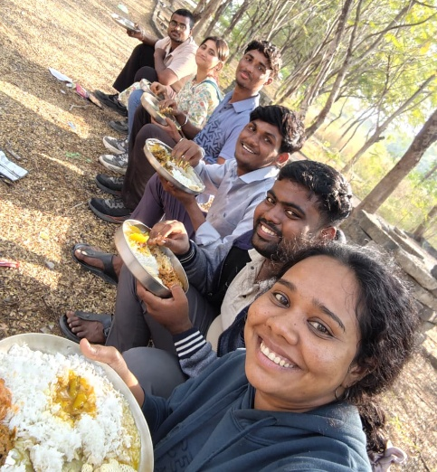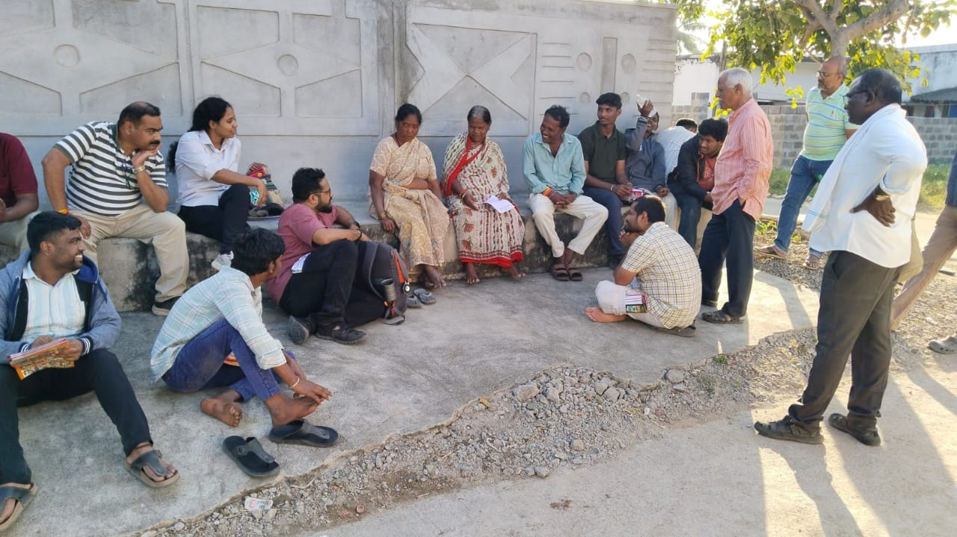

Above all, learning about Palle Srujana and its selfless service to society filled me with joy and hope.

